**Corona quiz 1**

**Hi friends, acquaintances, strangers, colleagues, inspirational heroes etc. I sincerely hope you are all staying safe and well. I find it very difficult to stay indoors and not do a lot so I thought I would do this quiz for anyone looking to fill in an hour.**

**It’s just a bit of fun but if people enjoy it I’ll do one a week and publish a leader board each time and maybe even offer a prize – BUT it is just for fun – it’s not a £20,000 rollover on Eggheads so please enter into the spirit of what it is meant to be.**

**RULES:**

* No cheating, googling, going over time etc – it’s just fun!
* Please do rounds in order, hopefully you will understand why later.
* You can come back to questions except in the timed round.
* Please send your answers back to me;

info@escapologist-cleethorpes.co.uk

by Wednesday 1st April 2020

(with a name)

**BEFORE YOU START:**

You will need a pen

Something that will count down from 90 seconds.

Watch the clip below ONCE and don’t jump ahead in the quiz.

<https://www.youtube.com/watch?v=yqLLDZvbG-U>

**GOOD LUCK HAVE FUN!**

**MATCH UPS**

**You’ve got the questions and answers just match them together**

**CHRISTMAS**

**LORDS A LEAPING DRUMMERS DRUMMING**

**SWANS A SWIMMING PIPERS PIPING GEESE A LAYING**

**MAIDS A MILKING LADIES DANCING**

|  |  |
| --- | --- |
| **12** |  |
| **11** |  |
| **10** |  |
| **9** |  |
| **8** |  |
| **7** |  |
| **6** |  |

**BOND GIRLS TO MOVIE**

**HOLLY GOODHEAD PUSSY GALORE MOLLY WARMFLASH HONEY RYDER PLENTY O’TOOLE MAY DAY**

**XENIA ONATOPP MARY GOODNIGHT**

|  |  |
| --- | --- |
| **DR. NO** |  |
| **GOLDFINGER** |  |
| **DIAMONDS ARE FOREVER** |  |
| **MAN WITH THE GOLDEN GUN** |  |
| **MOONRAKER** |  |
| **A VIEW TO A KILL** |  |
| **GOLDENEYE** |  |
| **WORLD IS NOT ENOUGH** |  |

**US POSTAL STATES eg California is CA**

**MA MD ME MI**

**MN MO MS MT**

|  |  |
| --- | --- |
| **Maine** |  |
| **Maryland** |  |
| **Massachusetts** |  |
| **Michigan** |  |
| **Minnesota** |  |
| **Mississippi** |  |
| **Missouri** |  |
| **Montana** |  |

**MOVIES - Top ten movies of all time**

**SCHINDLERS LIST FIGHT CLUB THE GODFATHER**

**DARK KNIGHT GOOD, BAD AND THE UGLY**

**PULP FICTION SHAWSHANK REDEMPTION**

**LORD OF THE RINGS: RETURN OF THE KING**

**12 ANGRY MEN THE GODFATHER PART II**

|  |  |
| --- | --- |
| **10** |  |
| **9** |  |
| **8** |  |
| **7** |  |
| **6** |  |
| **5** |  |
| **4** |  |
| **3** |  |
| **2** |  |
| **1** |  |

FAMILY FORTUNES

* For each question, the top 5 answers were taken from a **survey** of 18 – 35 year olds.
* Each correct answer is worth a point.
* If you put your top answer in the first box it will be worth 3 points.
* Top answer anywhere else – 1 point.
* 7 points maximum per question.

**Apart from the top answer the order is irrelevant.**

1. Not including Thriller, name the top 5 most popular Michael Jackson songs.
2. According to the survey, name top 5 UK landmarks.
3. According to the survey, name the 5 most popular cocktails.
4. According to the survey, name top 5 Tom Cruise movies.
5. According to the survey, name 5 things that get pulled.
6. According to the survey, name the 5 things people would want if stranded on a dessert island (not food and water).
7. According to the survey, 5 most well-known snooker players past and present.
8. According to the survey, top 5 most bought food items in a Chinese restaurant.
9. According to the survey, top 5 most visited states of the US.
10. According to the survey, name the top 5 board games (no batteries needed)

|  |  |  |  |  |  |
| --- | --- | --- | --- | --- | --- |
| **Q** | **TOP (3 points)** | **2** | **3** | **4** | **5** |
| **1** |  |  |  |  |  |
| **2** |  |  |  |  |  |
| **3** |  |  |  |  |  |
| **4** |  |  |  |  |  |
| **5** |  |  |  |  |  |
| **6** |  |  |  |  |  |
| **7** |  |  |  |  |  |
| **8** |  |  |  |  |  |
| **9** |  |  |  |  |  |
| **10** |  |  |  |  |  |

**GENERAL KNOWLEDGE**

|  |  |  |
| --- | --- | --- |
| 1 | In which city was Boris Johnson born? |  |
| 2 | How many members were in the Monty Python team? |  |
| 3 | Henry VIII had 2 wives executed – name them |  |
| 4 | Who was the original lead singer of Genesis? |  |
| 5 | What does galena and Cluedo have in common? |  |
| 6 | A word that can precede house and can follow hard… |  |
| 7 | 2004 Oscar winning movie, ALSO a collective noun for a group of rhinos |  |
| 8 | “Beam me up Scotty” was never said in a Star Trek film – true or false? |  |
| 9 | Which city has the largest cathedral in England? |  |
| 10 | Who did Djokovic beat in last years Wimbledon final? |  |
| 11 | Which American University awards the Pulitzer Prize? |  |
| 12 | At the 2000 TV Brit Awards who has a wardrobe malfunction and flashed most of her bra |  |
| 13 | What was the name of the coffee shop in Friends? |  |
| 14 | Which town and state was Cheers set? |  |
| 15 | Which famous solo artist wrote ‘red red wine’, UB40s famous hit? |  |
| 16 | What does the FC stand for in FCUK? |  |
| 17 | Which British city was the first to register a football club? |  |
| 18 | In 1937 what was the first frozen food available to purchase (vegetable)? |  |
| 19 | Which chess piece cannot move in a straight line? |  |
| 20 | Shepherds pie is made traditionally with what meat? |  |

**FACTUAL THREES**

No survey this time, just facts or official surveys……..ORDER IS IRRELEVANT….

|  |
| --- |
| **Top three most visited websites:** |
|  |
|  |
|  |

|  |
| --- |
| **By outlet, biggest fast food chains** |
|  |
|  |
|  |

|  |
| --- |
| **Top 3 spoken languages in the world** |
|  |
|  |
|  |

|  |
| --- |
| **Top 3 countries with most death from Selfies** |
|  |
|  |
|  |

|  |
| --- |
| **Top 3 songs of all time** |
|  |
|  |
|  |

**90 SECOND BLITZ**

**SET YOUR TIMER TO 90 SECONDS BEFORE YOU TURN THE PAGE!!!**

**5 QUESTIONS, 90 SECONDS FOR EACH, WRITE DOWN AS MANY ANSWERS AS YOU CAN BEFORE YOUR TIME RUNS OUT!!**

**90 SECOND BLITZ……**

**QUESTION 1**

**As many sports as you can possibly think of in 90 seconds, that don’t use a ball!!!**

**90 SECOND BLITZ……**

**QUESTION 2**

**Animals that don’t have 4 legs…..**

**90 SECOND BLITZ……**

**QUESTION 3**

**Name as many celebrity double acts (singing, comedy, anything) as you can……**

**90 SECOND BLITZ……**

**QUESTION 4**

**Name as many European countries as you can……**

**90 SECOND BLITZ……**

**QUESTION 5**

**Animated movies……**

**DINGBATS (see following 2 pages)**

**A WORD, SAYING, PHRASE, NAME – YOU UNDERSTAND!**

|  |  |
| --- | --- |
|  | **SHEET ONE** |
| **1** |  |
| **2** |  |
| **3** |  |
| **4** |  |
| **5** |  |
| **6** |  |
| **7** |  |
| **8** |  |
| **9** |  |
| **10** |  |
| **11** |  |
| **12** |  |
|  | **SHEET TWO** |
| **1** |  |
| **2** |  |
| **3** |  |
| **4** |  |
| **5** |  |
| **6** |  |
| **7** |  |
| **8** |  |
| **9** |  |
| **10** |  |
| **11** |  |
| **12** |  |

**DINGBATS SHEET 1**

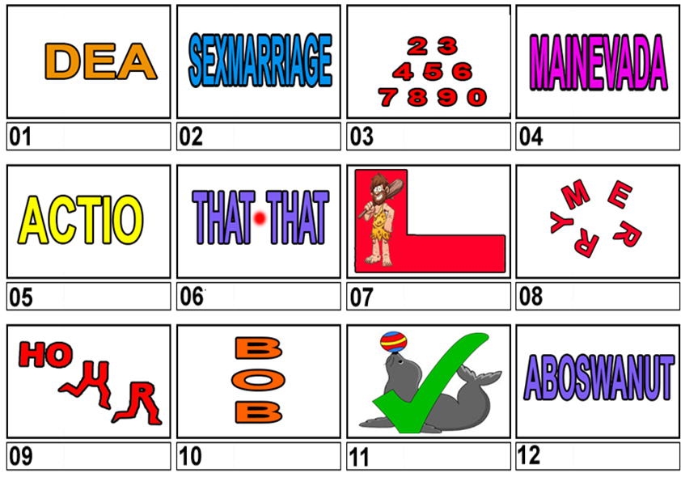

**DINGBATS SHEET 2**

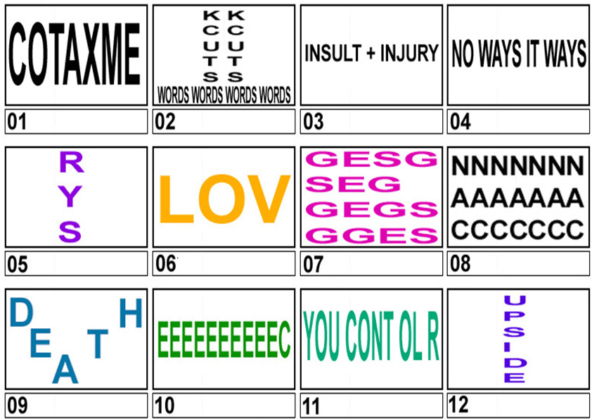

**Final question**

**From Peter Kay’s ‘Amarillo’ for Comic Relief…..**

**Name Every ‘personality’ who appeared in the video (real name or character is fine). The list includes all the non-human characters too and any character played by Peter Kay also. (The little people on Coronation Street are also not included) - DON’T WATCH IT AGAIN!!!!!**

|  |  |
| --- | --- |
| **1** |  |
| **2** |  |
| **3** |  |
| **4** |  |
| **5** |  |
| **6** |  |
| **7** |  |
| **8** |  |
| **9** |  |
| **10** |  |
| **11** |  |
| **12** |  |
| **13** |  |
| **14** |  |
| **15** |  |
| **16** |  |
| **17** |  |
| **18** |  |
| **19** |  |
| **20** |  |
| **21** |  |
| **22** |  |
| **23** |  |
| **24** |  |
| **25** |  |
| **26** |  |
| **27** |  |
| **28** |  |